APPENDIX
A. Maps and Tables
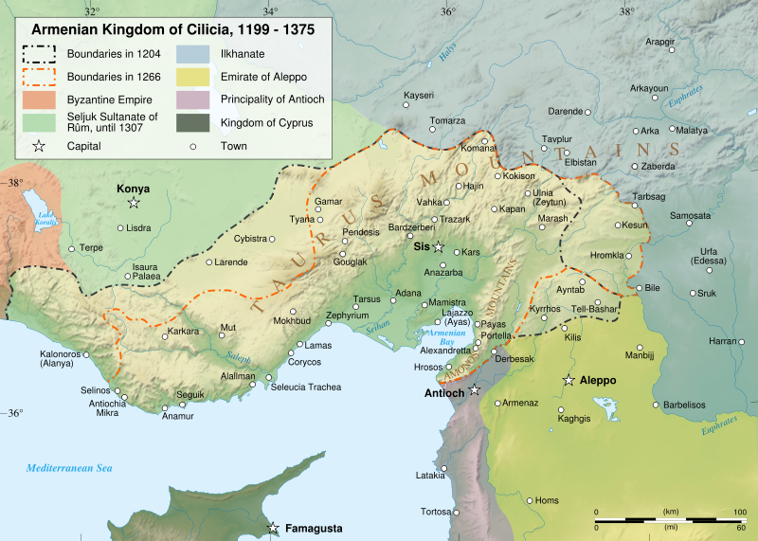
Map 1 - Source: http://en.wikipedia.org/wiki/Cilicia
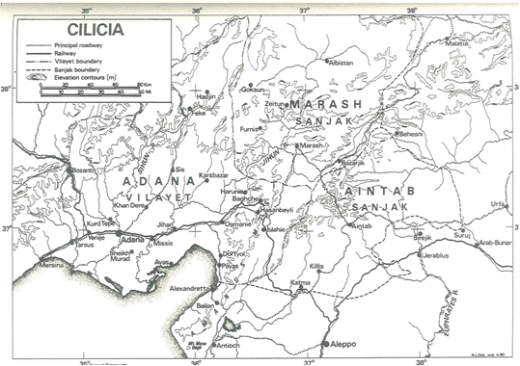
Map 2 - Source: Richard Hovannisian and Simon Payaslian, Armenian Cilicia, p. 501.
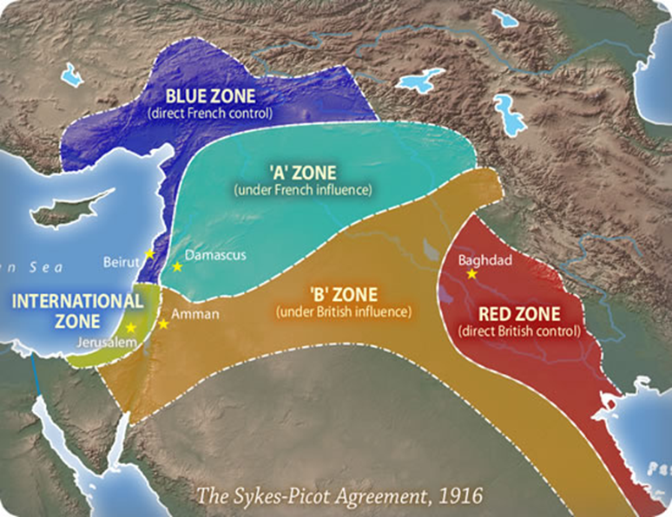
Map 3
Source: http://northeastedition.files.wordpress.com/2011/12/sykespicot.jpg

Table 1
Source: Kemal Karpat, Osmanlı Nüfusu (1830-1914), p. 210.
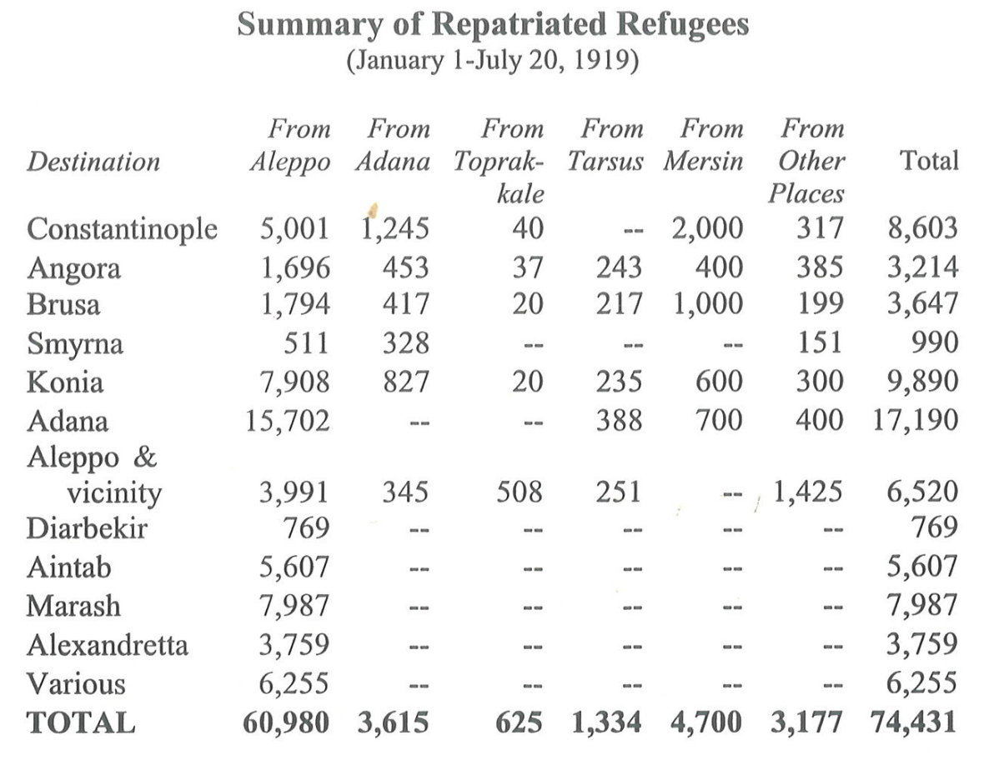
Table 2 – Source: Armenian Cilicia, p. 455.

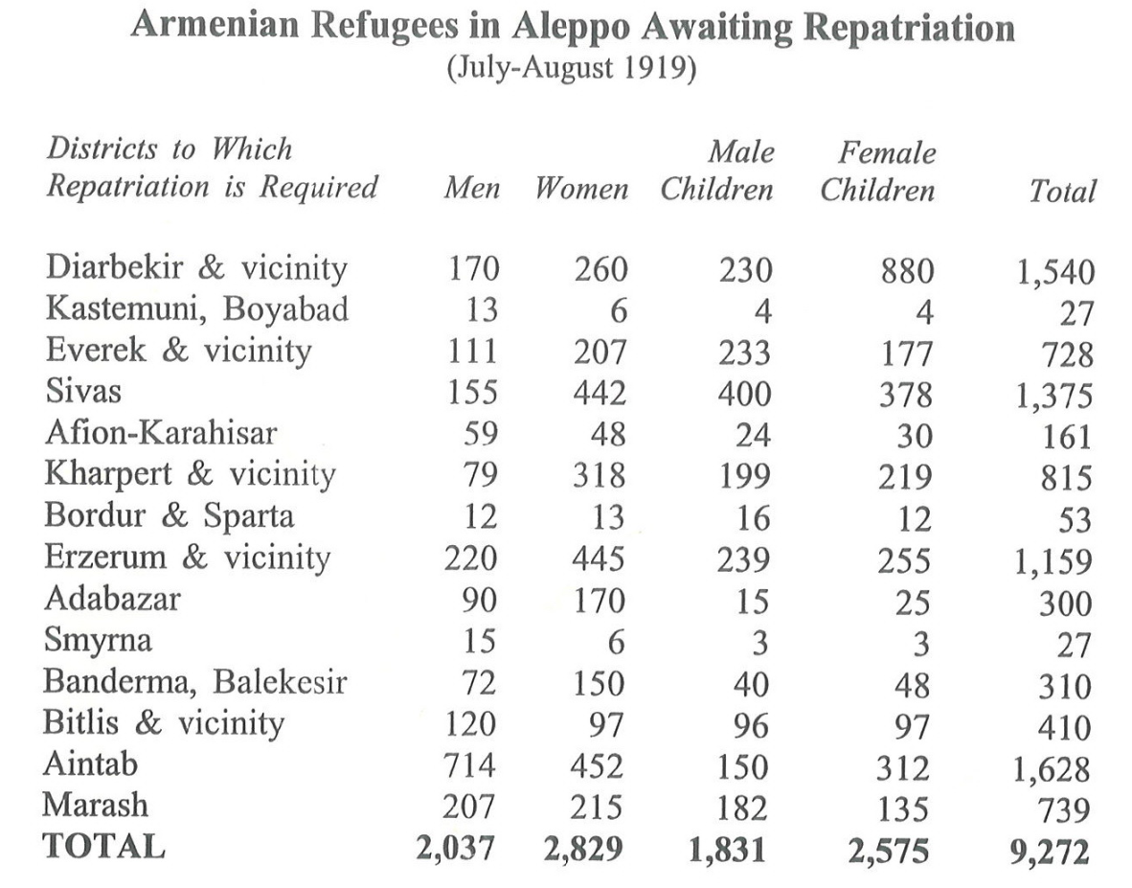
Table 3- Source: Armenian Cilicia, p. 456.
B. Photo Album

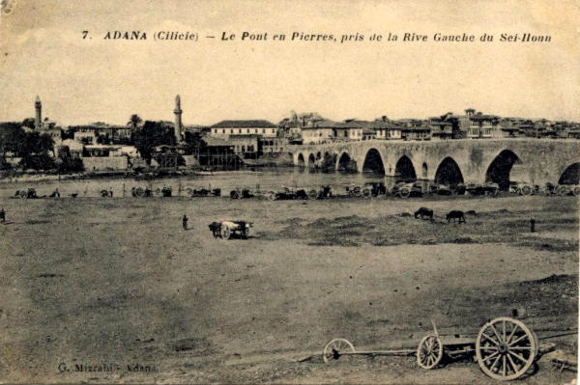

Adana- The Stone Bridge-1920
Source: http://www.eliecilicie.net/e_photos_3.htm

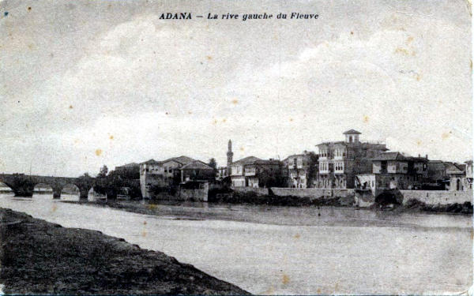

Adana- Left Bank-1920
Source: http://www.eliecilicie.net/e_photos_3.htm

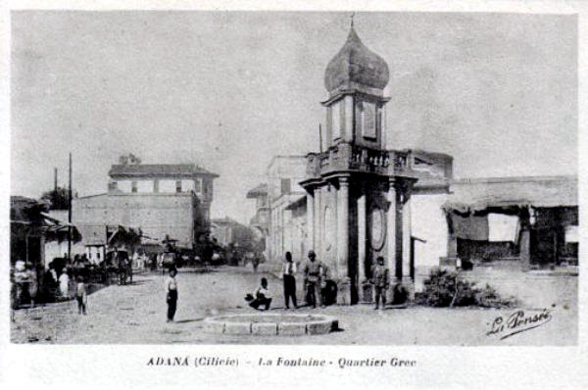
Adana – The Fountain- 1920
Source: http://www.eliecilicie.net/e_photos_3.htm

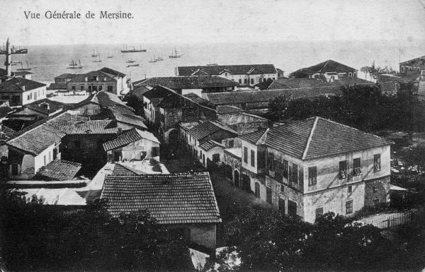

Mersin-1919
Source: http://www.eliecilicie.net/e_photos.htm

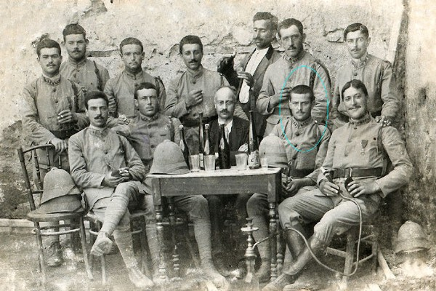

French Soldiers in Cilicia – 1919
Source: http://www.eliecilicie.net/e_photos.htm

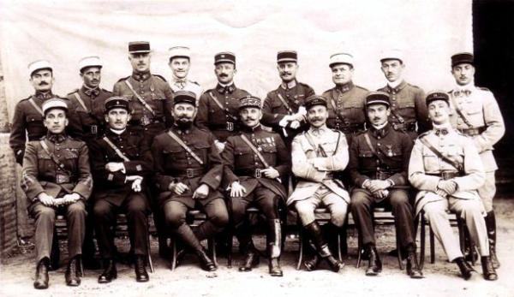

General Dufieux and his staff – 1921
Source: http://www.eliecilicie.net/e_photos_2.htm

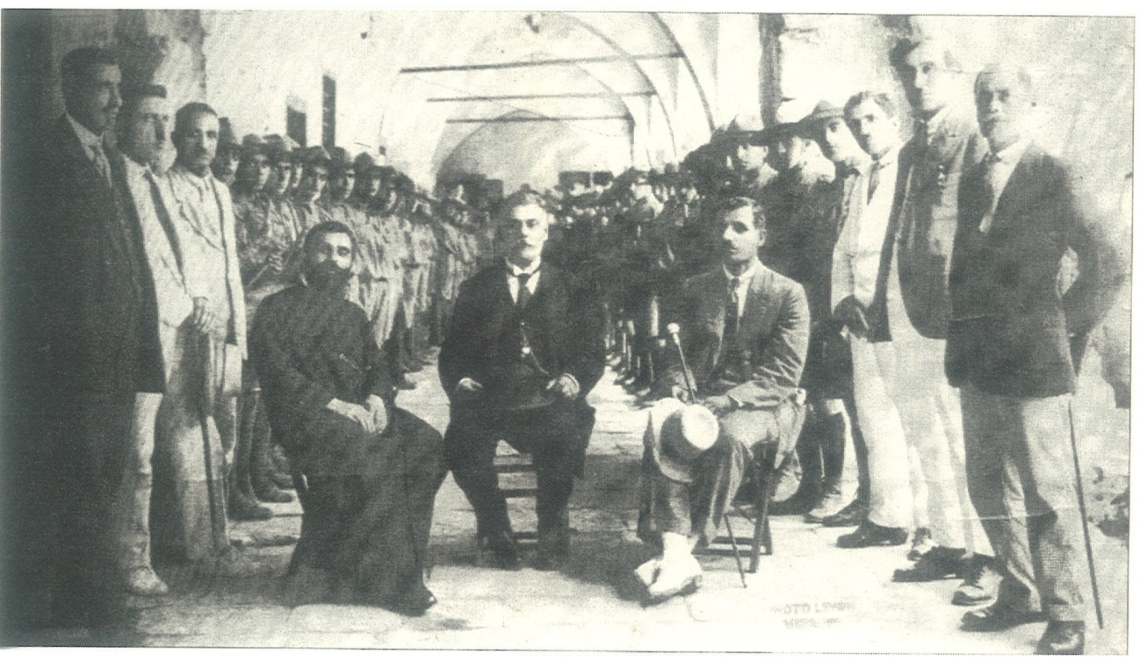

Mihran Damadian with Armenian Notables and Scouts- Mersin, 1921
Source: Armenian Cilicia, p. 494.

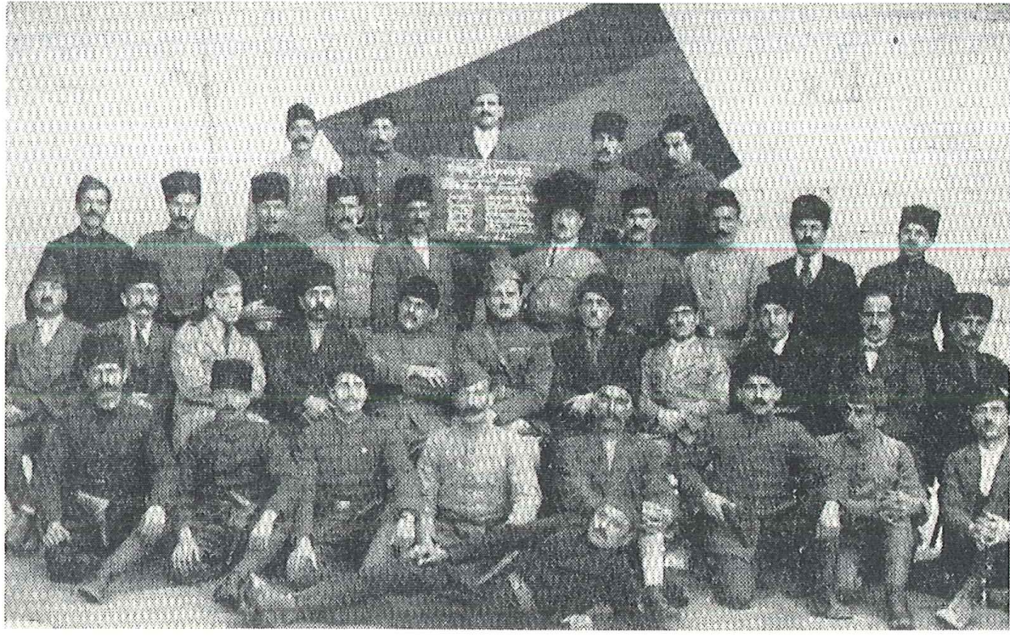

Armenians Soldiers and Commanders
Source: Armenian Cilicia, p. 26.

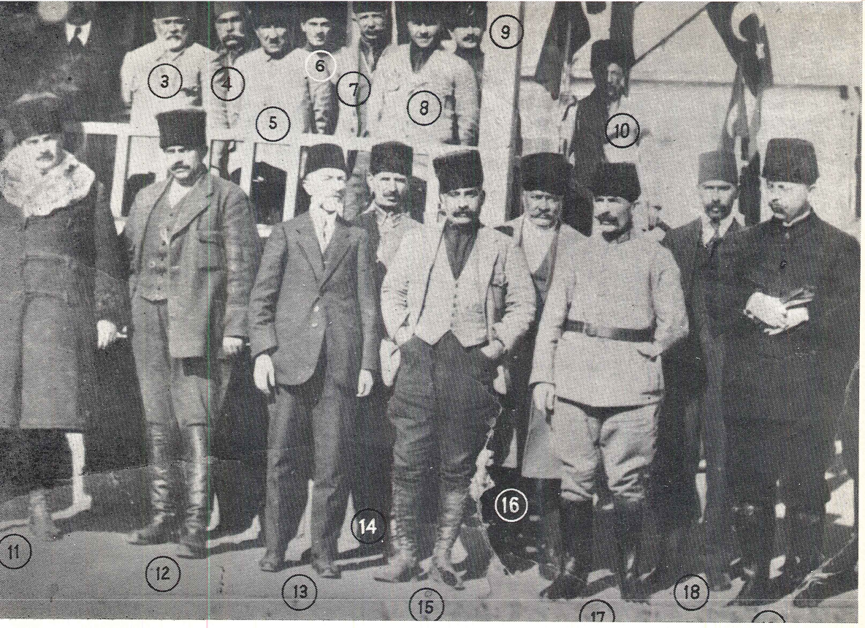

Turkish notables of Adana
Source: Yusuf Ayhan, Mustafa Kemal'in Pozantı Kongresi ve Adana'nın Kurtuluşu p. 68

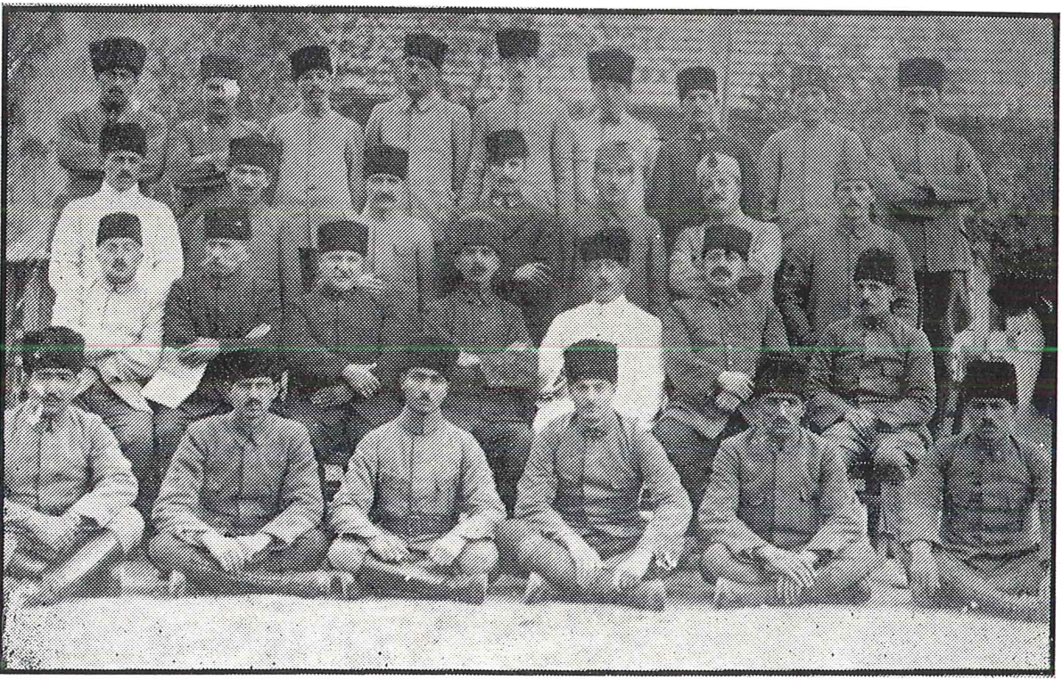

Turkish soldiers
Source: Mustafa Kemal’in Pozantı Kongresi ve Adana’nın Kurtuluşu, p. 87.

